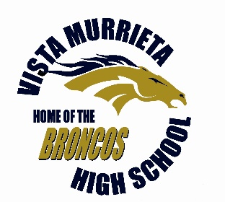  CHARACTER  LEADERSHIP  ATTITUDE  SCHOLARSHIP SERVICE  Principal  Celeste Scallion  Assistant Principals  Brianna Burow  Lloyd Dunn  Shane Sands  Rosa Velardez  Tamara Waddleton  Assistant Principal Athletics  Carl Galloway  Activities Director  Shannon Kush  Counselors  Karen Candaele  Claudia Hill  Debra Kimble  Silvia Osorio  Aurora Padilla  Eric Peterson  Dione Tyler  Sandie Valenzuela | Vista Murrieta High School  A California Gold Ribbon School and…a Tradition of CLASS...  IMPACT! Credit Recovery Class Syllabus  Course Title: IMPACT!  Teacher: Files  Course Description:  This credit recovery class is designed to provide students with the opportunity to revisit and reinforce key concepts from the core academic classes. Through targeted instruction and focused practice, students will work to improve their understanding of the course material and earn credit for the course. Students will work independently at their own pace.  Course Objectives:  - Review and consolidate understanding of fundamental concepts.  - Complete assignments and assessments to demonstrate mastery of the material.  - Engage in active learning to bridge gaps in learning and strengthen skills.  - Active participation in class discussions and activities.  - Timely submission of assignments and assessments.  - Respectful communication with the teacher and peers.  - Adherence to classroom rules and regulations as outlined in the classroom contract.  Communication:  Students are encouraged to ask questions during class or visit the teacher during office hours.  Email communication for clarifications and inquiries is welcome.  Any important announcements will be shared through Canvas.  Credit Recovery Plan:  Office hours: Thursdays by appointment room W235  Academic Integrity:  Plagiarism and cheating are strictly prohibited. All work should be your own.  Accessibility and Accommodations:  If you have any specific accommodations, please inform the teacher at the earliest opportunity.  Disclaimer:  This syllabus is subject to change at the discretion of the teacher to accommodate the needs of the class.  By participating in this class, you acknowledge that you have read, understood, and agree to abide by the information provided in this syllabus.  Student Signature: ____________________________ Date: ______________  Parent/Guardian Signature: _____________________ Date: ______________  Teacher Signature: _____________________________ Date: ______________
 | Vista Murrieta High School 28251 Clinton Keith Road, Murrieta, CA 92563 (951)894-5750

